**NATURAL LANGUAGE PROCESSING**

RINSHAN KOLAYIL

**INDEX**

|  |  |  |
| --- | --- | --- |
| Index | Topic | Page |
| **1** | **Neural networks** |  |
| 1.1 | Introduction to neural networks | 3 |
| 1.2 | Primitive neuron | 4 |
| 1.3 | Introduction to neuron and perceptron |  |
| 1.4 | Sigmoid neuron |  |
| 1.5 | Activation function & Types of activation functions |  |
| 1.6 | Cost functions |  |
| 1.7 | Gradient descent |  |
| 1.8 | Stochastic gradient descent |  |
| 1.9 | The feedforward model of neural networks |  |
| 1.10 | Disadvantages of feedforward model |  |
| 1.11 | Applying weights to the feedforward model |  |
| 1.12 | Back propagation algorithm |  |
|  |  |  |
|  |  |  |

**INTRODUCTION TO NEURAL NETWORKS**

Neural networks, also known as artificial neural networks inspired from human brain. It consist of input layer, one or more hidden layers and an output layer. Each node or artificial neuron connects one another with weight and bias. If the output of any node is above the threshold, the node is activated and then sending the data to the next layer. Otherwise no data is passed along the next layer of network.

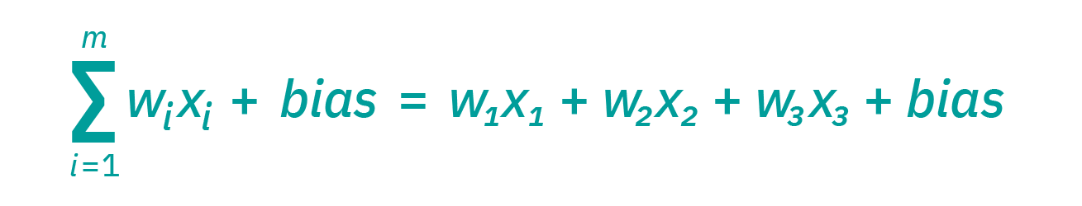

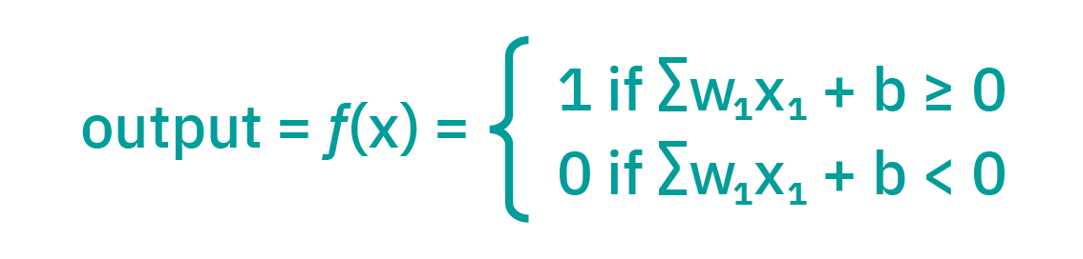

The weights help determine the importance of any given variable with large one contributing more significantly to the output compared to other outputs.

The output layer or decisions depend on the previous layers. Let’s say an example, since yesterday rains heavy you might bring an umbrella today.

History

* Warren McCulloch and Walter Pitts open the subject for creating computational model of NN
* D.O Hebb created the hypothesis based on the mechanism of neural plasticity
* Frank Rosenblatt invented the perceptron, the first neural network
* Ivakhnenko - First function NN with many layers

**HOW NEURAL NETWORK SIMILAR WITH BIOLOGICAL NEURON**

|  |  |
| --- | --- |
| **BIOLOGICAL NEURON** | **ARTIFICIAL NEURON** |
| Dendrites Brings inputs from other neuron to current neuron | X1, X2, X3 |
| Synaptic gap modifies the signal (Signals in the form of electrical and chemical form) | Weights |
| Axon | Output connection |
| Soma act as the processing unit and process the input from dendrites | Activation function |

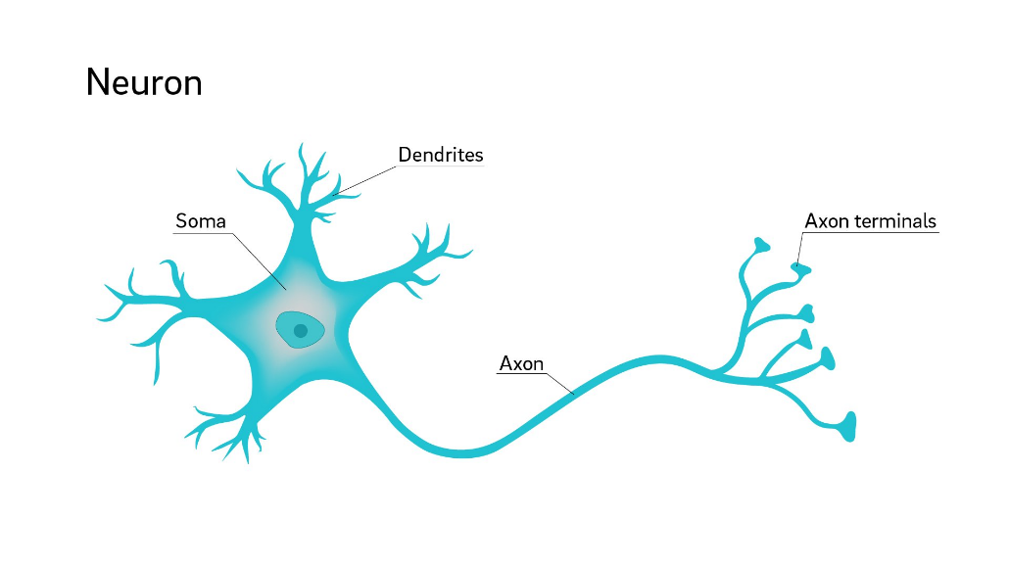

**PRIMITIVE NEURON**

The smallest neuron of processing available to a programmer of a particular machine

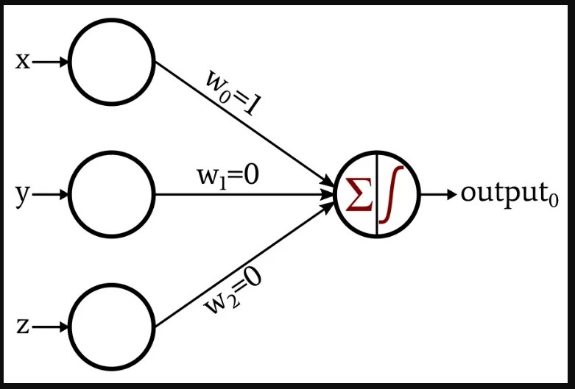**INTRODUCTION TO NEURONS AND PERCEPTRON**

Perceptron act as a linear classifier and it can do binary classifier. Perceptron output is one if weighted sum of inputs greater than the threshold.

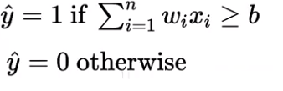

**SIGMOID FUNCTION**

Sigmoid function will compress the output ranges. Small change in the input will cause only small change in output.

If z is 100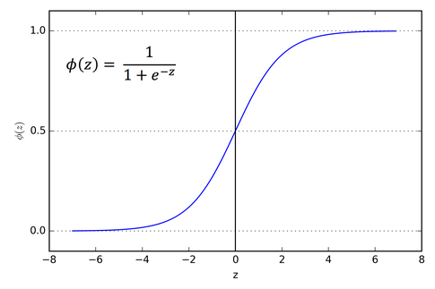, then sigma (z) close to 1. If z is 200, then sigma (z) close to 0. In other words, the output range is lies between 0 and 1 after applying the sigmoid function.

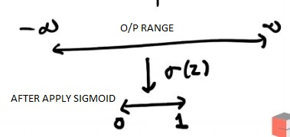

Let’s say an example (For binary classification), if output of a class 1 is 0.7, then the probability of class zero is (1 - 0.7).

* P(Y=1) = sigma (z)
* Then P(Y=0) = 1 – (z)

**HOW DO WE TRAIN A PERCEPTRON?**

We have following for training,

* One model (Perceptron)
* One loss function

**SIGMOID NUERON**

In a perceptron, the output is equal to one if the weighted sum of inputs is greater than the threshold, otherwise zero but in a sigmoid neuron, small changes in input cause only small changes in output.

Let’s say an example, threshold is 50K

* One person will buy a card if he earns 50K or more
* In the case of perceptron, he will not buy a car if he has 49.9K. In the case of sigmoid neurons, he will.

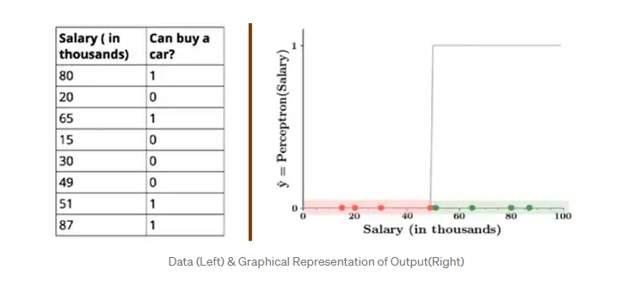

**ACTIVATION FUNCTION**

Activation function maps the resulting values between 0 to 1 or -1 to 1 (Depending on the function)

Types of activation functions

* Linear or identity activation function
* Sigmoid or Logistic activation function
* Tanh or hyperbolic tangent activation function
* ReLU (Rectified Linear unit) activation function
* Leaky ReLU

https://towardsdatascience.com/activation-functions-neural-networks-1cbd9f8d91d6